**Experiment No.4**

**Aim:** Edit/compile/run a program to read the radius of a circle and print the area of the circle.

**Program A:**

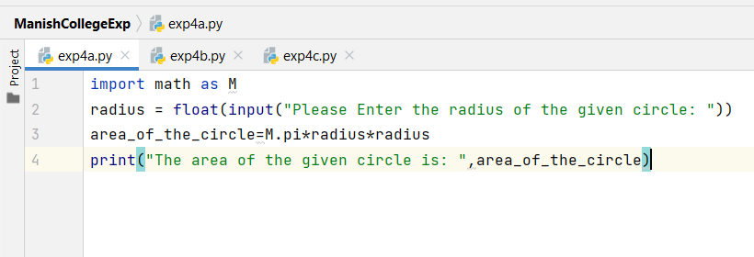

**Output:**

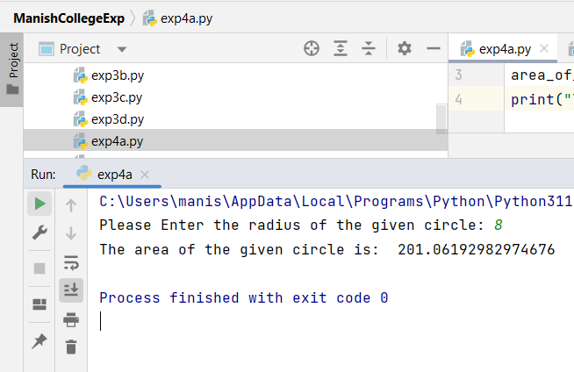

**Program B:**

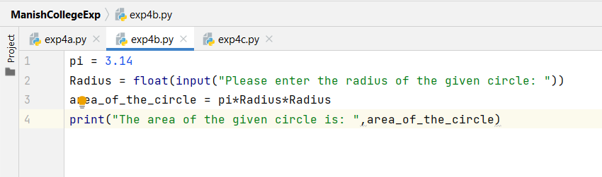

**Output:**

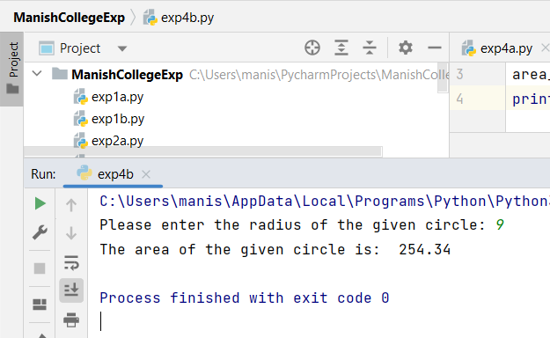

**Program C:**

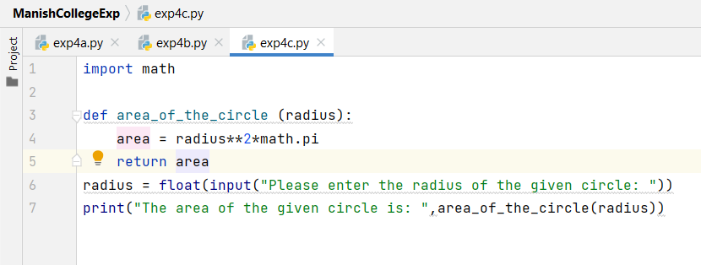

**Output:**

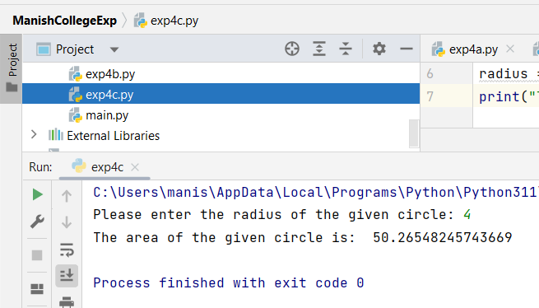

**Program D:**

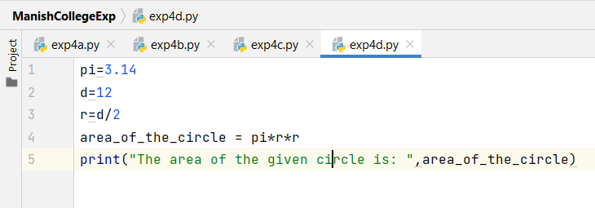

**Output:**

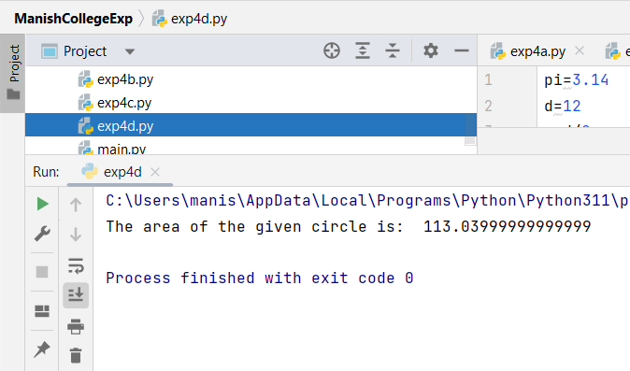

|  |  |  |  |
| --- | --- | --- | --- |
| **Practical Performance**  **(4)** | **Writeup & Oral**  **(4)** | **Attendance**  **(2)** | **Total**  **(10)** |
|  |  |  |  |